Unbounded Use Case Maps

UC - 01
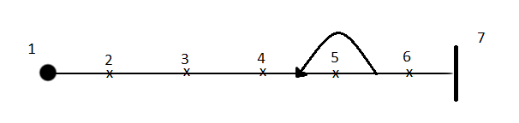

Tag | Responsibility
1 | User starts the game application
2 | System responds with an opening screen, waiting for user input
3 | User selects to start a new game from the menu provided
4 | System builds the player listing, board, and player movement options
5 | User enters player information by clicking on available add button, specifies bith the name and class they which to play as
6 | User starts the game
7 | The game has started

UC – 02

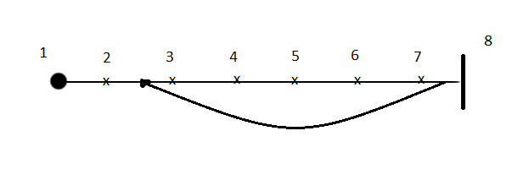

Tag | Responsibility
1 | Current player of the game selects the move option from the available list
2 | System responds by highlighting all available clearings that connected to player's connected clearings
3 | Player selects a valid area for the character movement
4 | System checks the area to see if it is available for the player to move to
5 | System records “M-” followed by the clearing name to the player's log
6 | System moves player to new area
7 | System highlights clearings connected to new area
8 | Player has finished moving to the desired clearing

UC-03
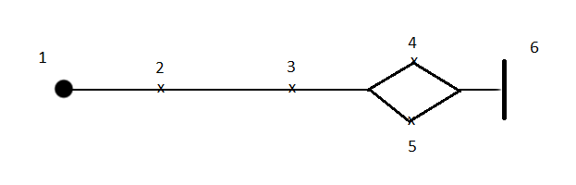

Tag | Responsibility
1 | User start their turn and is unhidden if they are currently hidden
2 | User selects hide from the available list of commands
3 | System generates value to determine if player becomes hidden
4 | Player becomes hidden, their tile becomes green until they become unhidden
5 | Player stays unhidden (hiding failed)
6 | The player has attempted to become hidden

UC-04

Tag | Responsibility
1 | User starts their turn
2 | User selects the search option from the list of commands
3 | System responds with a dialogue that contains options for searching
4 | User has selected to search clearing, system searching the clearing and gives the player access to hidden items if found
5 | User selects loot, the player loots the available treasure and adds it to their inventory
6 | The player has searched or looted their clearing

UC-05

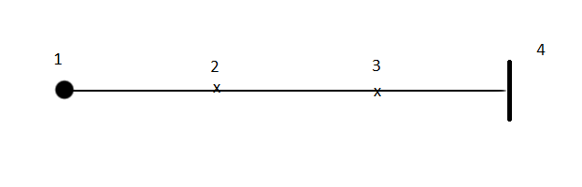

Tag | Responsibility
1 | User selects a player from the list
2 | User clicks on the option to show detailed card
3 | System responds by displaying the character detail sheet for the selected player's class
4 | Player detail has been displayed

UC-06
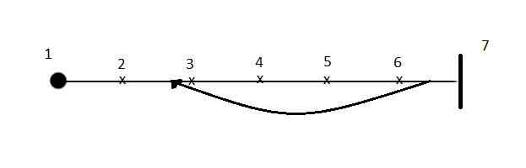
Tag | Responsibility
1 | All players have sent their turn and two players are unhidden on the same clearing
2 | A combat user interface is opened for the players
3 | The luring phase of combat is initiated, users select the enemies they want to lure
4 | The charging phase of combat is initiated
5 | Players select which maneuver they would like to use and which attack they would like to use
6 | Attacking phase is resolved, harm and fatigue is calculated and applied
7 | No more than one player is on the clearing or nothing has happened for 2 rounds, combat is resolved

